Help Document for
SMI-S ATT

Ryan Li

Revision History

Date | Version | Author(s) | Change Summary
04/14/12 | 1.0 | Ryan Li | Initial revision.

Table of Contents

1 Introduction 4
2 Steps to get SMI-S ATT 4
3 Tests Dir Hierarchy 4
3.1 Ini Test Case 5
3.1.1 Im: Test Invoke Methods 5
3.1.2 Prop: Test Instance Properties 5
3.2 Py Test Case 5
4 Environment Setup 5
5 How to run test suite 5
5.1 Usage 5
5.2 Examples 6
6 Features 6
6.1 TestCase Level Setup and Teardown 6
6.2 TestSuite Level Setup and Teardown 7
6.3 Instance Properties Test 8
6.4 Association Test 8
6.5 Invoke Method Test 8
6.6 Indication Test 8
6.7 Performance test by running Multiple Threads 8
7 Supported INI Entries 8
7.1 Common entries 8
7.1.1 SleepAfterExe 8
7.1.2 SleepBeforeExe 8
7.1.3 Note 8
7.1.4 Rst 9
7.1.5 checkX 9
7.2 Print 9
7.3 emuInstance 9
7.4 queryInstance 9
7.5 InvokeMethod 10
7.6 queryAssociator 10
8 Test Results 10
8.1 Att.log 10
8.2 Att.html 11
9 Third Part Libraries Used 11
10 Supports 11

Introduction

This document is intended to the end users on how to run the different test suites based on the individual requirement.

Tests Dir Hierarchy

Ini Test Case

Im: Test Invoke Methods
This place is used to host ‘Invoke Method’ ini test case. Each Dir underneath is a test suite.

Prop: Test Instance Properties
This place is used to host ‘Property’ ini test case. Each Dir underneath is a test suite.

Py Test Case
This place is used to place test case write in Python. Each Dir underneath is a test suite.
The python testcase should write using pyUnit directly.

Environment Setup
ATT is platform independent; it works on Windows and Linux.

Following software are required to run ATT.

- Python 2.7 or previous installed. (Python 3.0 should work with other features except ‘indication’ test, since ‘indication’ used ‘Twisted’ which is not compatible with Python 3.0 yet when wrote this document)

- Twisted installed. http://twistedmatrix.com/Releases/Twisted/12.0/Twisted-12.0.0.tar.bz2
(Twisted is required only when test ‘indication’ feature)

- Pywbem installed. http://sourceforge.net/apps/mediawiki/pywbem/index.php?title=Main_Page

How to run test suite

Usage

[root@shalnx132 cimTest]# python run.py --help
Usage: run.py [options]

Options:
-h, --help show this help message and exit
-s CIMSRV, --cimsrv=CIMSRV
cim server https connection [default:
http://10.32.191.225:5988]
-u CIMUSR, --username=CIMUSR
cim user [default: admin]
-p CIMPWD, --password=CIMPWD
cim password [default: #1Password]
-n CIMNS, --namespace=CIMNS
namespace used [default: root/emc]
-v, --verbose put more information
-w HTMLREPORT, --htmlReport=HTMLREPORT
Generate Html Report.(less console output)
-i INDICATION, --indication=INDICATION
enable indication test
-m MODE, --mode=MODE Ini or python test [default: iniProp]
-t TESTS, --tests=TESTS
test to be run.
-r THREADSNUM, --threadsNum=THREADSNUM
run in multiThreads [default: 1]

Examples
python run.py -m iniIm -t 'suite=ts_pool,tests=t0_debug' -w yes
python run.py -m py -t 'suite=suite1,tests=t' -w no
python run.py -m iniIm -t 'suite=debug,tests=t0_debug' -w no

Features

TestCase Level Setup and Teardown
[setup]
[[Action1:print]]
SleepAfterExe=0.1
SleepBeforeExe=0.2
msg=t0seupMsg
[[Action2:astTrue]]
msg=forceFalse1

[execute]
[[Action3:print]]
msg=t0execMsg

[teardown]
[[Action5:astTrue]]
msg=forceFalse1

Since ATT is built based on python UnitTest, Setup and Teardown logic is exactly same as python unitest framework. http://docs.python.org/library/unittest.html

[setup] section is optional, ATT will execute [setup] section if it is defined in testcase.
Same applies to [teardown] section.

In one Ini testcase, [setup] section is used to server this testcase’s setup steps, and [teardown] section is used to server testcase’s teardown steps.

When execute this testcase, the directions in [setup] section will be executed, then [execute] section get executed, then [teardown] section get executed.

If [setup] failed, [execute] and [teardown] section will not be execute, this Ini testcase is filed as ‘Error’ in test result.

If [setup] succeeded, the [teardown] method will be run regrardless [execute] succeeded or not.

TestSuite Level Setup and Teardown
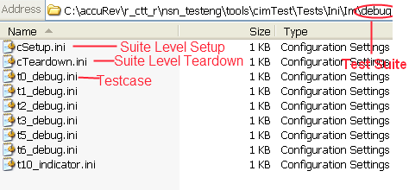

Suite Level Setup and Teardown logic is exactly same as setupClass() and teardownClass() of python unitest framework. http://docs.python.org/library/unittest.html#setupclass-and-teardownclass

Each directory is recognized as a testsuite, cSetup.ini is recognized as Suite level setup test, while cTeardown.ini recognized as suite level teardown test. That is to say, before run one or more testcase(s) in the suite, cSetup.ini will be execute once, then execute the tests, after all tests executed, cTeardown.ini will be executed once.

Instance Properties Test

Association Test

Invoke Method Test

Indication Test

Performance test by running Multiple Threads
This feature allow one test be run simultaneous in multiple threads, the uniq object need be named with keywords ‘${ThreadName}’ to avoid conflict .

[setup]
[[init]]
note=init poolName in t0_debug.ini
poolName=pool_test
lunName=lun_test_${ThreadName}
lunSize=10

Supported INI Entries

Common entries

SleepAfterExe
Sleep seconds before execute the action.
Example:
[[Action1:print]]
SleepAfterExe=0.1
SleepBeforeExe=0.2

SleepBeforeExe
Sleep seconds after execute the action.

Example:
[[Action1:print]]
SleepAfterExe=0.1
SleepBeforeExe=0.2

Note
The Note is the description of current action, its value will be print in log and report when execute the action.

Example:
[[Action5: queryInstance]]
note=qI, make sure lun created
rst=ac5Rst
cql=select * from cim_storagevolume where cim_storagevolume.elementname='${lunName}'
check1=astAtLeastOneInst(${ac5Rst})

Rst
This directive used to save the section result. The result can be referenced by variable ${rst}

Example:
[[Action1:emuInstance]]
rst=ac5Rst

checkX
The checkX followed by a certain assert statement to check the section result is passed or failed.

[[Action1:emuInstance]]
note=eI, get cim_storageconfig service.
rst=myInstList
clsName=cim_storageconfigurationservice
check1=astAtLeastOneInst(${myInstList})

Print
Print action is used to server develop/debug purpose, it just print the ‘msg’ to the log and console.

Example:
[[Action1:print]]
msg=t0seupMsg

emuInstance
[[Action1:emuInstance]]
note=eI, get cim_storageconfig service.
rst=myInstList
clsName=cim_storageconfigurationservice
check1=astAtLeastOneInst(${myInstList})

queryInstance
[[Action2: queryInstance]]
note=qI, make sure has the pool inst.
rst=ac2Rst
cql=select * from cim_storagepool where cim_storagepool.elementname='${poolName}'
check1=astAtLeastOneInst(${ac2Rst})

InvokeMethod
[[Action4: InvokeMethod]]
note='iM, create lun'
waitJobComplete=true
expectedJobResult=Success
rst=act2Rst
methodName= CreateOrModifyElementFromStoragePool
par1= ${myInstList}[0].path
par2= ElementName='${lunName}'
par3= ElementType=pywbem.Uint16(2)
par4= InPool=${ac2Rst}[0].path
par5= Size=pywbem.Uint64(${lunSize})

queryAssociator
[[Action6: queryAssociator]]
note='qA, make sure Asso created'
rst=act6Rst
waitJobComplete=true
ObjectName=${ac5Rst}[0].path
AssocClass='cim_allocatedfromstoragepool'
check1=astAtLeastOneInst(${act6Rst})

Test Results

Att.log
In ‘Report’ directory, att.log is the log of the ATT, it is always enabled.

INFO 00:39:05 cim.py Line:57 Thread-2:===Executing test:cSetup_execute_Thread-2===
INFO 00:39:05 cim.py Line:57 Thread-1:===Executing test:cSetup_execute_Thread-1===
INFO 00:39:05 cim.py Line:57 Thread-2:init poolName and poolSizeInByte
INFO 00:39:05 cim.py Line:57 Thread-1:init poolName and poolSizeInByte
INFO 00:39:05 cim.py Line:57 Thread-2:===Executing test:t0_debug_setup_Thread-2===
INFO 00:39:05 cim.py Line:57 Thread-1:===Executing test:t0_debug_setup_Thread-1===
INFO 00:39:05 cim.py Line:57 Thread-2:init poolName in t0_debug.ini
INFO 00:39:05 cim.py Line:57 Thread-1:init poolName in t0_debug.ini
INFO 00:39:05 cim.py Line:57 Thread-2:./Tests/Ini/Im/ts_pool/t0_debug.ini
INFO 00:39:05 cim.py Line:57 Thread-1:./Tests/Ini/Im/ts_pool/t0_debug.ini
INFO 00:39:05 cim.py Line:57 Thread-2:Section: Action1:emuInstance

Att.html

Att.html is enabled if launch ‘run.py’ with ‘-w’ switch, the testcases are categorized by test suite, each testcase has the result and log inside.
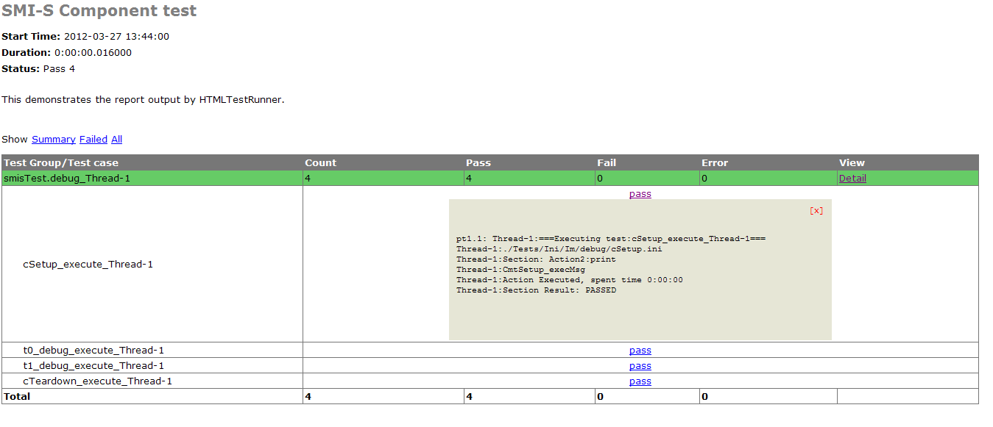

Third Part Libraries Used
HTMLTestRunner.py http://pypi.python.org/pypi/HTMLTestRunner/0.8.0
Twist http://twistedmatrix.com/
Pywbem http://pywbem.sourceforge.net/
ConfigObj http://www.voidspace.org.uk/python/configobj.html

Supports

This listed developer of the ATT, please sent email to them to get support.

Wang, Harbee (Harbee.Wang@emc.com)
Liang, Ryan (Ryan.Liang@emc.com)
Li,Ryan (Ryan.Li@emc.com)

